|  |
| --- |
|  |
| **Evaluative study on the interactive ability of phenolic acids derived from pomegranate peel with Cu2+ ions as examined using UV-Vis spectroscopy** |
| How do phenolic acid derivatives obtained from pomegranate peel interact with Copper (II) ions? As investigated using UV Visible Spectroscopy |
|  |
|  |
| **Word Count: 7036** |

|  |
| --- |
|  |

Contents

1 Abbreviation Chart 5

2 Introduction and Rationale 6

3 Research Question 8

4 Background Information 8

4.1 Copper 8

4.2 Ligands and Denticity 9

4.3 Chelation 9

4.4 Ligand Strength and Colored Complexes 10

4.5 Polyphenols present in PP 12

4.6 Thermodynamics in Chelation 15

4.7 Effect of Solvent 17

4.8 Effect of pH Environment 19

4.9 Determination of Extent of Interaction 21

5 Hypothesis 22

5.1 Hypothesis 1 – Solvent Performance 22

5.2 Hypothesis 2 – Effect of PPP Mass Used 22

5.3 Hypothesis 3 – Effect of Metal Ion concentration 23

5.4 Hypothesis 4 – Effect of Metal Ligand Voluminal Ratio 23

5.5 Hypothesis 5 – Effect of pH Environment 23

6 Preliminary Investigations 24

**6.4 UV-Vis Spectroscopy** 24

***6.4.1 Lambda Max Determination*** 24

***6.4.2 Standard Calibration Curve*** 24

6.1 Selection of Extraction Method 25

6.2 Selection of Boiling Duration 25

6.3 Selection of Solvents 26

6.4 Selection of PPP Mass 26

7 Variables 26

7.1 Independent 26

7.2 Dependent 26

8 Preparation of Reagents 27

8.1 Preparation of ligand solutions 27

8.2 Preparation of CuSO4 standards of varying concentrations 27

8.3 Preparation of complex solutions 27

8.4 Preparation of pH 2 buffer 28

8.4.1 Reagent 1 Preparation (0.20 moldm-3 Hydrochloric Acid) 28

8.4.2 Reagent 2 Preparation (0.20 moldm-3 Potassium Chloride) 28

8.4.3 Buffer Preparation 28

8.5 Preparation of pH 5 buffer 29

8.5.1 Reagent 1 Preparation (0.10 moldm-3 Glacial Acetic Acid) 29

8.5.2 Reagent 2 Preparation (0.10 moldm-3 Sodium Acetate Trihydrate) 29

8.5.3 Buffer Preparation 29

8.6 Preparation of pH 7 buffer 30

8.7 Preparation of complex solutions with buffer 30

9 Data Collection 30

9.1 Qualitative Data 30

9.1.1 Complex Solutions for Varying Solvents 30

9.1.2 Complex Solutions at Varying PPP Mass (± 0.001) (g) 31

9.1.3 Complex Solutions at Varying Copper Concentrations (moldm-3) 31

9.1.4 Complex Solutions for Varying Water:Cu2+ Voluminal Ratios (cm3) 31

9.1.5 Complex Solutions at Varying pH and PPP Mass (± 0.001) (g) (0.050M Cu2+) 32

9.1.6 Complex Solutions at Varying pH and PPP Mass (± 0.001) (g) (0.075M Cu2+) 32

9.2 Quantitative Data – Absorbance Value 33

9.2.1 Complex Solutions for Varying Solvents 33

9.2.2 Complex Solutions at Varying PPP Mass (± 0.001) (g) 33

9.2.3 Complex Solutions at Varying Copper Concentrations (moldm-3) 33

9.2.4 Complex Solutions for Varying Water:Cu2+ Voluminal Ratios (cm3) 34

9.2.5 Complex Solutions at Varying pH and PPP Mass (± 0.001) (g) (0.050M Cu2+) 34

9.2.6 Complex Solutions at Varying pH and PPP Mass (± 0.001) (g) (0.075M Cu2+) 34

10 Data Processing – EI% 35

10.1 Complex Solutions for Varying Solvents 35

10.2 Complex Solutions at Varying PPP Mass (± 0.001) (g) 36

10.3 Complex Solutions at Varying Copper Concentrations (moldm-3) 36

10.4 Complex Solutions for Varying Water:Cu2+ Voluminal Ratios (cm3) 36

10.5 Complex Solutions at Varying pH and PPP Mass (± 0.001) (g) (0.050M Cu2+) 37

10.6 Complex Solutions at Varying pH and PPP Mass (± 0.001) (g) (0.075M Cu2+) 37

11 Analysis 38

11.1 Analysis 1 – Solvent Performance 38

11.2 Analysis 2 – Effect of PPP Mass Used 39

11.3 Analysis 3 – Effect of Metal Ion concentration 40

11.4 Analysis 4 – Effect of Metal Ligand Voluminal Ratio 40

12 Conclusion 40

13 Evaluation 41

13.1 Strengths 41

13.2 Weaknesses 41

14 Further Scope 42

15 References 42

16 Appendix 47

16.1 Uncertainties 47

16.1.1 Varying copper standards 47

# 1 Abbreviation Chart

|  |  |
| --- | --- |
| **Abbreviation** | **Explanation** |
| **PP** | pomegranate peel |
| **PPP** | pomegranate peel powder |
| **EDTA** | Ethylenediaminetetraacetic acid |
| **GA** | Gallic acid |
| **EA** | Ellagic acid |
| **EI** | extent of interaction |

# 2 Introduction and Rationale

Ensuring access to clean water for everyone is one of the UN’s Sustainable Development Goals(United Nations). Nearly 800 million people worldwide lack reliable access to clean drinking water(Water.org). Unequal access to clean drinking water is estimated to cost the world around $260 billion USD annually(Water.org). One of the main causes for the contamination of water is due to wastewater effluent from factories which dangerously increase the amount of heavy metals such as Copper in the waterways.(Mokarram, Saber and Sheykhi). The deleterious effects of heavy metal poisoning of drinking water are well documented and known - heavy metal contamination can lead to the development of cardiovascular diseases, neuron damage, and an increased risk of cancer and diabetes (Rehman, Fatima and Waheed).

The conventional EDTA filtering method for remediating heavy metal contaminated water that was taught in Chemistry class is efficient (due to its hexadentate nature) but EDTA’s resistance to bacterial biodegradation(Hinck, Ferguson and Puhaakka) and the adverse effects of its complexes (Crisponi, Nurchi and Lachowicz) nullifies its effectiveness in today’s eco-conscious world. Hence research has been undertaken in order to find sustainable, low-cost, organic sources of chelating agents (Rashed and Tayh).

Pomegranates are enjoyed by many across the world, thanks to their taste and numerous health benefits (Zarfeshany, Asgary and Javanmard). 2.5-3 million tons are produced annually and are used in various industries such as in the beverage and food industry(Görgüç, Gençdağ and Yılmaz). However, PPs, which consist of approximately 30% of the whole fruit’s weight(Mo, Ma and Gao), are generally discarded, even though they have been identified as a valuable reservoir of organic substances (Figure 1).

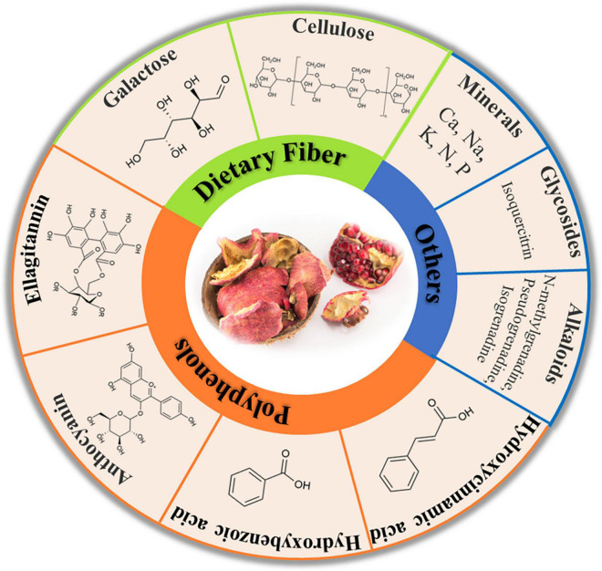

*Figure 1: Some bioactive compounds present in PPs* (Mo, Ma and Gao)

Their phenolic profile consists mainly of tannins, flavonoids, and phenolic acids and these polyphenols consist of up to 50% of the weight composition of PPs (depending on the extraction method and testing method used) (Mo, Ma and Gao). This high polyphenolic content makes PPs a promising green alternative to traditional chelating agents for treating heavy metal contaminated water – since PPs have been known to effectively interact with, and neutralize, heavy metal ions such as copper (Rashed and Tayh). Hence, the present study aims to explore the mechanism of the interaction between the polyphenols of the PP and the copper ions as well as to optimize it by varying variables such as the PPP mass, extraction solvent, copper ion concentration, metal ion-ligand ratios, and pH.

# 3 Research Question

This led me to formulate the research question – **How do phenolic acid derivatives obtained from pomegranate peel interact with Copper (II) ions?**

The study explores the optimal mass of PPP, extraction solvent, copper ion concentration, metal-ligand ratio, and pH environment which yields the highest EI. To understand the interactions that take place between the phenolic derivatives and the copper (II) ions, we need to look into the individual components first.

# 4 Background Information

## 4.1 Copper

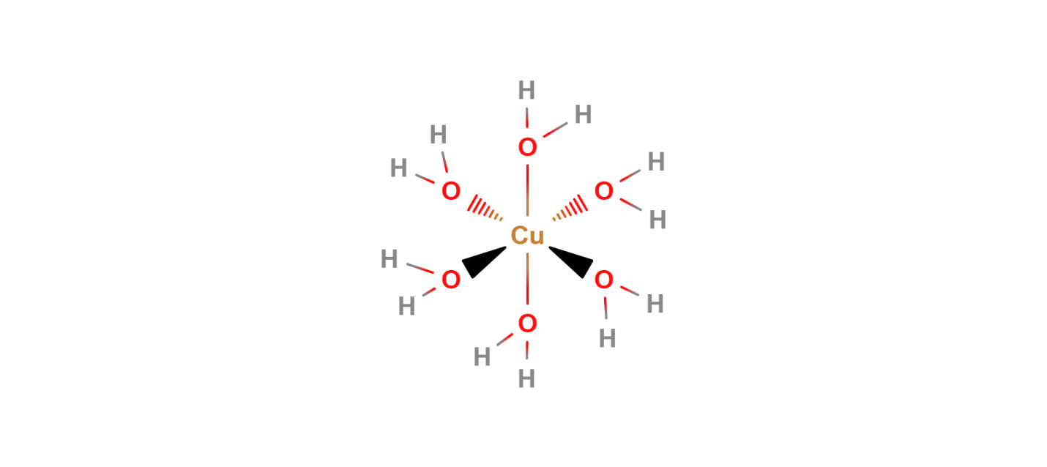In the center of the interaction is the metal ion, copper, which is the third-most used metal with applications in industries such as wiring and construction (U.S. Congress, Office of Technology Assessment). Although essential for bone and cardiovascular health(Araya, Olivares and Pizarro), copper has been linked to several adverse effects in the body(Manne, Kumaradoss and Iska). It is mainly introduced into the body through water (Manne, Kumaradoss and Iska) – which is the motive behind this research in reducing copper content in water.

*Figure 2: The octahedral structure of the complex [Cu(H2O)]6 ]2+ (Hexaaquacopper(II))* (MolView)

Located in the d-block of the periodic table, copper is a transition metal with a unique electronic configuration of [Ar]4s13d10. This configuration is taken by the copper atom as it is more stable having an incomplete s-orbital than an incompletely filled d-orbital(Brown and Ford). Copper can exist in two oxidation states including as Cu+, however, it is most commonly found as Cu2+ with the loss of one electron from the outermost 4s-subshell and the loss of another electron from the 3d-subshell. In its more stable +2 oxidation state, copper ions have a maximum of six binding sites as shown in Figure 2. These binding sites allow molecules called ligands to form coordinate bonds with the copper ion, forming copper complexes and thus remediating heavy-metal contaminated water.

## 4.2 Ligands and Denticity

As briefly outlined in the previous section, ligands are molecules or ions that bind to a central metal ion to form a substance called a complex – the polyphenolic derivates from PP being the ligands used in this study. Ligands have one or more atoms with a pair of electrons that can be used to form one or more dative bonds with the metal ion. They act as a Lewis base through electron pair donation, while the metal atom/ion acts as a Lewis acid via accepting them.

Ligands are classified by two factors, their denticity and strength. Denticity is a characteristic of a ligand’s binding site(s). For example, as seen in Figure 3, when a polydentate ligand approaches a metal ion, multiple dative bonds are formed between the metal ion and the binding sites of the ligand. This process is a special type of complexation called chelation.

## Screenshot 2024-02-06 011810.png4.3 Chelation

Having origins from the Greek word for ‘claw,’ (Flora and Pachauri) chelation differs from complexation by the denticity of the participating ligands. Monodentate ligands like water offer only one binding site, leading to complexation as seen in Figure 2. Polydentate ligands (also known as chelating agents) meanwhile interact with the central metal ion through multiple binding sites (such as inFigure 3); thus, leading to chelation. Chelating agents wrap around the metal ion, forming ring-like/cage-like structures called chelate complexes or chelates which boost the stability of the complex - this is referred to as the chelate effect(Lancashire). Chelation is the primary type of interaction that takes place between the copper (II) ions and the phenolic derivates from the PP as will be detailed in the following sections.

*Figure 3: Pictorial representation of complexation (top) and chelation (bottom)* (Flora and Pachauri)

Another factor that is used to categorize ligands is their strength (as mentioned in the Section 4.2), which will be detailed upon in the following section.

## 4.4 Ligand Strength and Colored Complexes

When the ligands interact with the metal atom/ion, the degeneracy (energy-level) of the metal ion's d-orbital is lifted, resulting in the formation of t2g and eg sub-levels. The energy difference between these sub-levels is influenced by both the metal ion’s and ligand’s properties. This determines the wavelength of light which is absorbed by the complex, thus resulting in the complementary color being seen. This process is visually detailed in Flowchart 1.

The color of a metal complex is determined by the extent to which the d-orbitals of the metal ion is split. The spectrochemical/ligand strength series (Figure 4) arranges some commonly studied/used ligands in the increasing order of their ability to split the energy levels of the metal ions (Tsuchida).

|  |
| --- |
| **I−< Br−< S2−< Cl−< F− < OH−< H2O < SCN−< NH3< CN−< CO**  *Figure 4: Spectrochemical Series* (Tsuchida) |

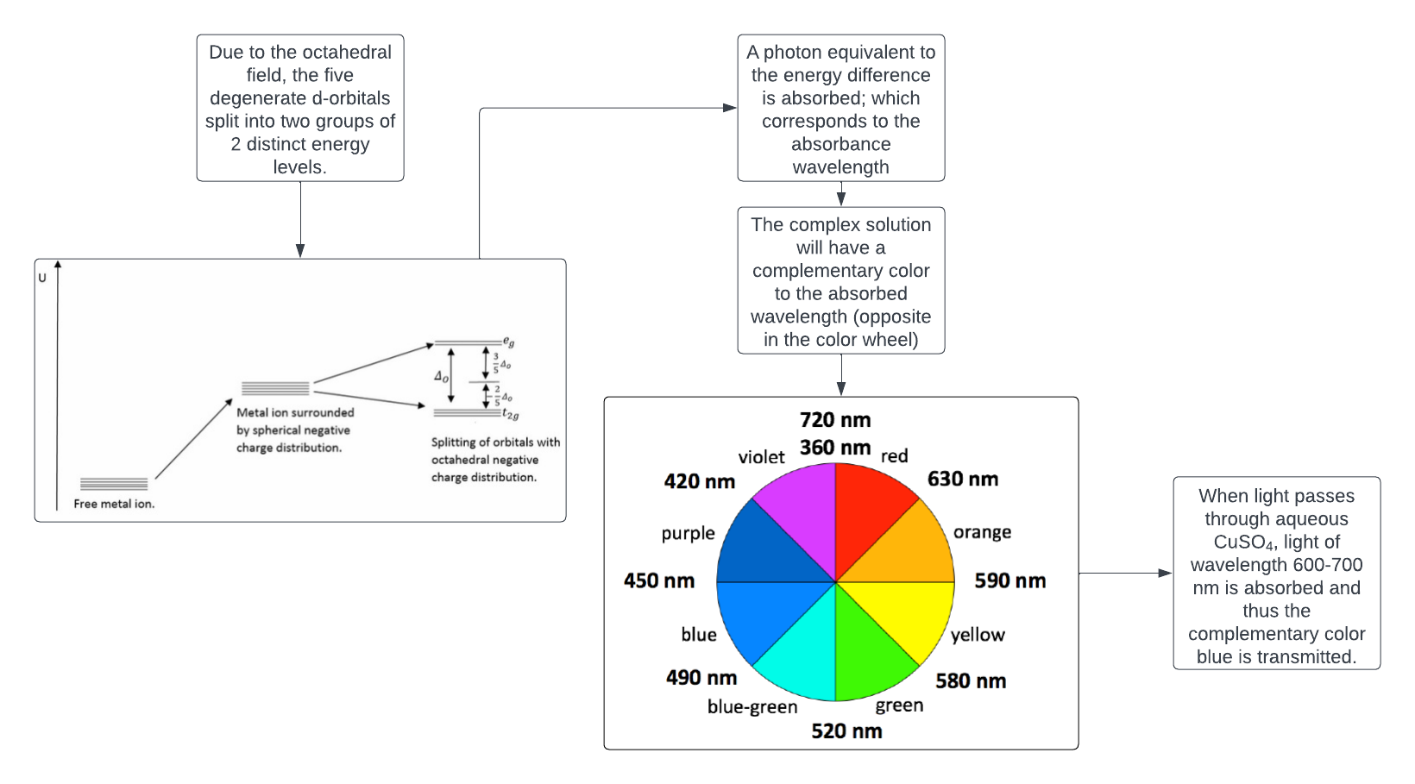

*Flowchart 1: The process of d-d splitting by the octahedral field and the formation of colored complexes* (Lucidchart)(LibreTexts)

Flowchart 1

*: The process of d-d splitting by the octahedral field and the formation of colored coordinate complexes* (Lucidchart)

Given that the function of the polyphenolic derivates from PP as chelators is now established, it is reasonable to delve deeper into the specificities of these chelate-metal ion interactions – first, however, this requires an understanding of the polyphenolic profile of PPs.

## 4.5 Polyphenols present in PP

Phenolic compounds, such as polyphenols, are a major group of compounds which have been recognized for their contribution to our health(Belščak-Cvitanović, Durgo and Huđek). They are characterized by the presence of multiple phenol groups in the molecule, making them effective natural metal chelating agents as identified in literature(Belščak-Cvitanović, Durgo and Huđek). There are many polyphenolic compounds present in PPs, from tannins and flavonoids to various phenolic acids (Mo, Ma and Gao); the primary ones identified being the phenolic acids GA and EA (which constitute approximately 60-80% of the total phenolic content depending on the extraction conditions) (Figure 6(Kupnik, Leitgeb and Primožic)). Other polyphenols present in large quantities in PPP extracts include flavonoids such as catechin and epicatechin (Figure 6(Kupnik, Leitgeb and Primožic)).

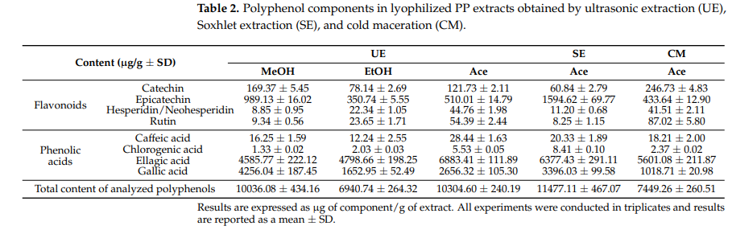

*Figure 6: Chemical constituents of PPP extracts in varying extraction conditions* (Kupnik, Leitgeb and Primožic)

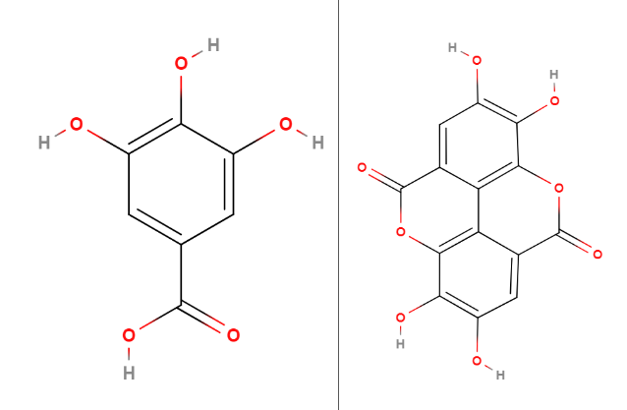

*Figure 7: Molecular structures of two major polyphenolic constituents of PP, GA and EA (right to left)* (MolView)

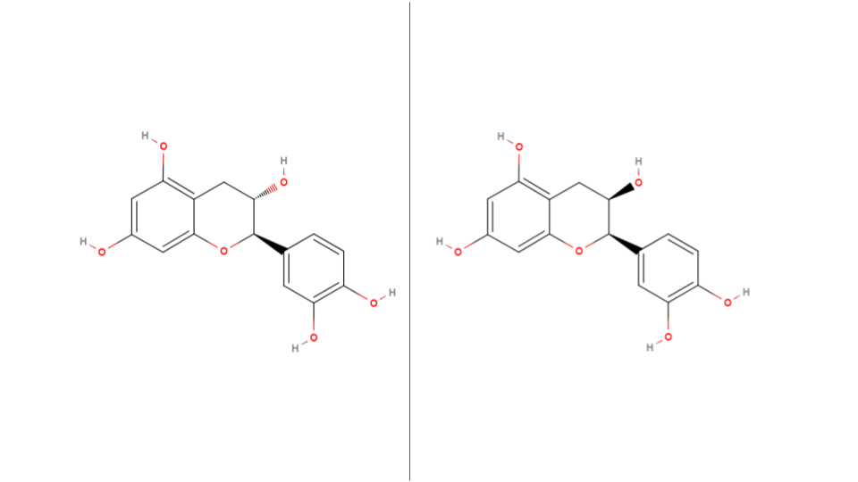

*Figure 8: Molecular structures of two minor polyphenolic constituents of PP, catechin and epicatechin (right to left)* (MolView)

The multiple hydroxyl and carboxyl groups on the GA and the hydroxyl groups on the EA can donate electrons to the Cu2+ ions. GA can only undergo complexation as the oxygen atom in central hydroxyl group cannot form multiple dative bonds – thus GA should be considered as a bidentate ligand which can only bind with a singular copper ion. EA, on the other hand, can undergo chelation with copper as it has four hydroxyl groups. This is shown in Figure 9.

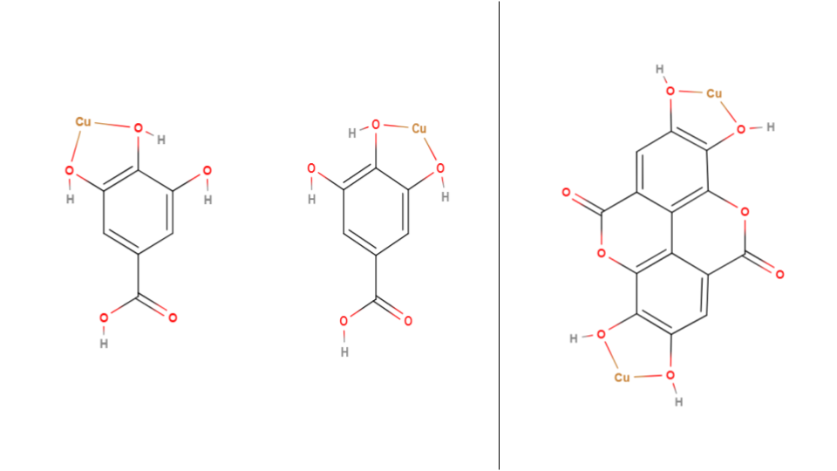

*Figure 9: Binding sites in GA (left and center) and EA (right) with bonds with copper shown.*

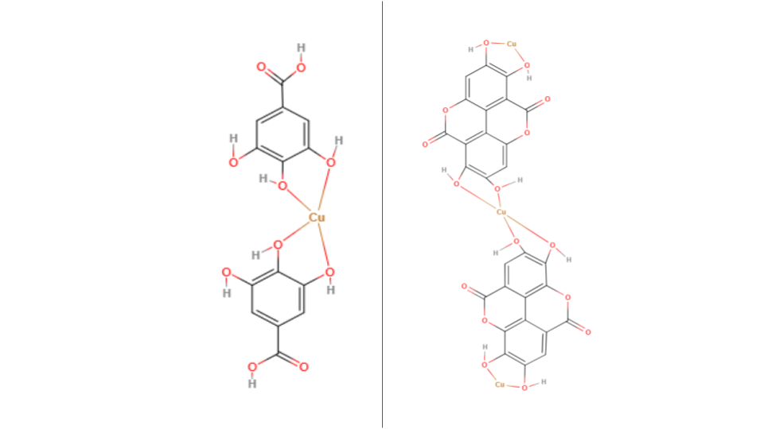

*Figure 10: Binding sites in GA (left and center) and EA (right) with bonds with copper shown.*

These two ligands, along with other polyphenols present in PPP extract (Figure 6(Kupnik, Leitgeb and Primožic)), contribute to the PP’s ability to treat heavy metal contaminated water. This prompted me to explore PPs further and their role in the process of water purification.

Now, the thermodynamic properties of the interaction between the ligands and copper will be elaborated upon since they determine the driving force for probing the extent of metal-ligand interaction.

## 4.6 Thermodynamics in Chelation

In an aqueous medium (through which most copper is ingested by the body (Manne, Kumaradoss and Iska)), copper (II) ions exist as the complex Hexaaquacopper (II) (Figure 2) (Clark). This is due to the sum of the hydration enthalpies of copper and sulfate ions (-2100 (Chieh) and -1099 (Barret) kJmol-1 respectively) being higher in magnitude than the lattice enthalpy of CuSO4 (which will be used to prepare the copper solution) (3066 kJmol-1 (Yoder and Flora)), thus resulting in the solvation of the copper ions by water molecules and the formation of Cu-hydrated complexes like the aforementioned one.

When a chelating agent like GA or EA approaches the hydrated copper complex, an associative substitution/ligand exchange mechanism comes into play as shown in Figure 11(MolView). This is a spontaneous mechanism as the reaction enthalpy is negative and there is an increase in entropy (due to the loss of multiple aqua ligands in the Hexaaquacopper (II) complex), which results in an overall negative Gibbs free energy value (as shown by Equation 1). Moreover, the chelate is more stable than the hydrated complex due to the previously mentioned chelate effect.

[1]

|  |
| --- |
| **ΔG** = Change in Gibbs free energy | **ΔH** = Enthalpy | **T** = Temperature | **ΔS** = Change in entrophy |

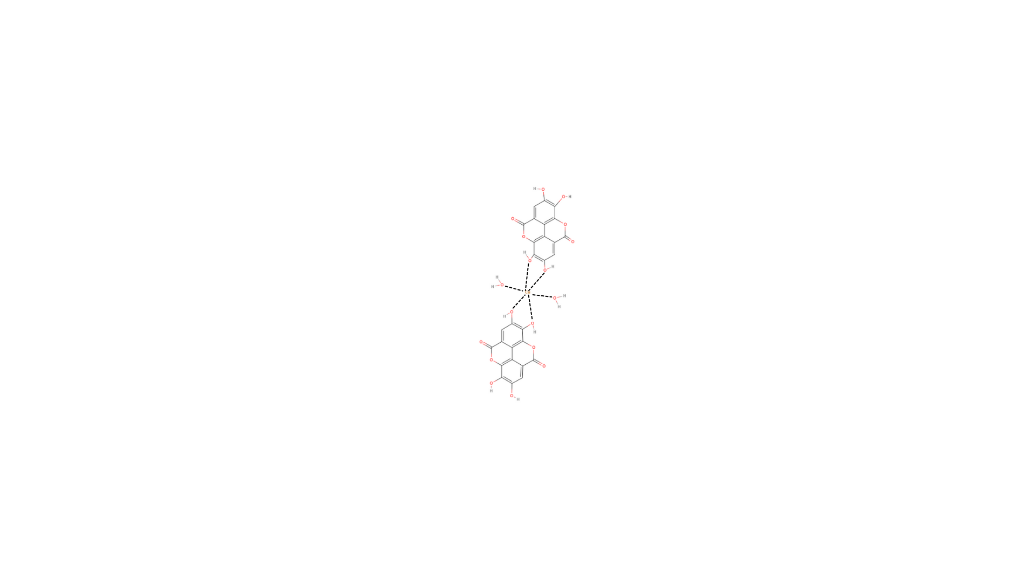

*Figure 11: The transient state in the associative substitution mechanism for when the EA approaches and beings to interact with the copper atom as the aqua ligands disassociate* (MolView)

Having understood the modes of interaction, we can now comprehensively investigate the variables of the study in order to optimize and predict the results of the experimentation.

## 4.7 Effect of Solvent

Before the complexation and chelation processes can begin, ligands must first be extracted from the PPP. The solvent with the highest degree of interaction with the ligands – which will allow it to overcome the intermolecular forces keeping the ligands together (Burke) – will have the highest extraction efficiency and thus the most optimal EI values. The major factors affecting the interaction are the solvent’s polarity and intermolecular forces (Burke).

Firstly, the polarity of the solvent determines its ability to interact with the polar groups of GA and EA, namely the carboxylic acid group of GA and the hydroxyl groups of both molecules. Polarity may play a lesser role in the solvation of EA than GA, which can be attributed to EA’s much higher molecular mass than GA (PubChem) and due to EA containing several non-polar arene groups that predominantly interact with other non-polar molecules (Burke).

A lower proportion of the overall mass is accounted for by the polar groups in EA than GA (as both have 4 hydroxyl groups) while the larger structure of EA hinders polar interactions through steric hinderance, and thus - although polarity plays a vital role in the solubility of these **compounds in a solvent – the higher molecular mass of EA would result in lower extraction yields for it than GA in a polar solvent**.

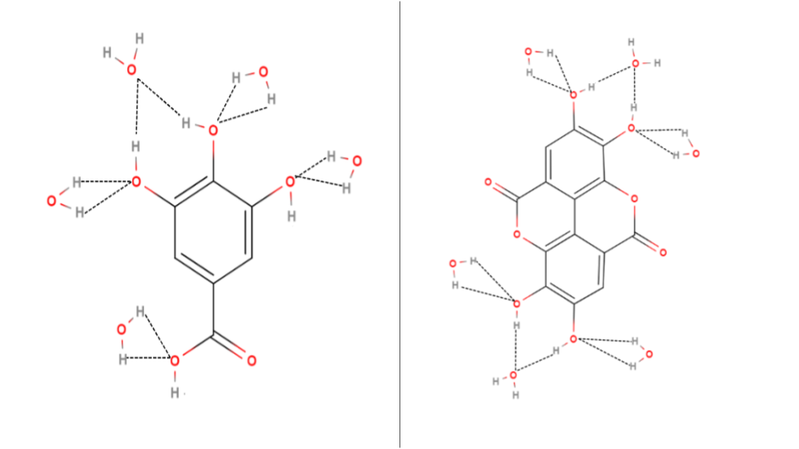

*Figure 12: An example of a hydrated cluster of GA (left) and EA (right). Water molecules form hydrogen bonds (dash lines) with the hydroxyl groups in each ligand, dissolving it* (MolView)*.*

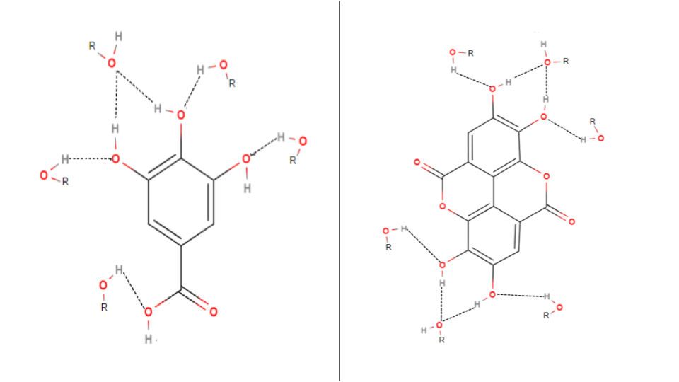

*Figure 13: A generic solvation cluster of GA (left) and EA (right). The hydroxyl group of the alcohol molecules (ROH) form hydrogen bonds (dash lines) with the hydroxyl groups in each ligand, dissolving it* (MolView)*.*

Secondly, although not as strong as the hydrogen bonding present in the polar interactions in GA and EA, the intermolecular van der Waals forces also hold the potential to impact a solvent’s solvation capabilities. A greater van der Waals interaction between the solvent and solute molecules translates to higher solvation efficiencies – especially in the case of EA which has large aromatic ring groups which can interact extensively with large, non-polar molecules through the van der Waals forces due to the higher surface area and electron density that the aromatic groups in EA have over smaller arenes such as GA.

Literature data validates this - GA(Daneshfar, Ghaziaskar and Homayoun) and EA(Bala, Bhardwaj and Hariharan) are more soluble in methanol and ethanol than water (with ethanol being in the middle for both acids). Methanol, with its moderate polarity and surface area, balances both solubility factors and thus has the most optimal results. The superior performance of ethanol relative to water suggests that van der Waals forces play a more significant role in dissolving the ligands than polarity does since the effect of water’s higher polarity is offset by ethanol’s higher van der Waals forces in terms of their solvation performance. This finding will be useful for the framing of the first hypothesis.

The selection of these solvents was based upon their high availability and low-cost, which connects with the sustainable focus of this study.

## 4.8 Effect of pH Environment

Another factor to optimize is the pH of the complexation environment, which can play a significant role in the complexation efficiency of the PPP extract.

In alkaline conditions, the extracted GA will deprotonate to a greater degree (due to the presence of a carboxylic group). As it has a low pKa value of 4.40 (F.), the carboxylic acid group will fully deprotonate in high pH conditions, forming the gallate anion (Figure 14). This ionization increases the negative charges on the molecule, enhancing its ability to act as a ligand since the ion offers more binding sites – specifically the deprotonated carboxyl and hydroxyl groups – hence increasing the EI.

EA will have a similar situation since, in alkaline conditions, the pH of the solution will exceed its dual pKa values (Bianconi, Gidari and Souma), thus all the hydroxyl groups present in the molecule will deprotonate and result in the formation of the ellagate anion (Figure 14), leading to greater complexation between EA and copper.

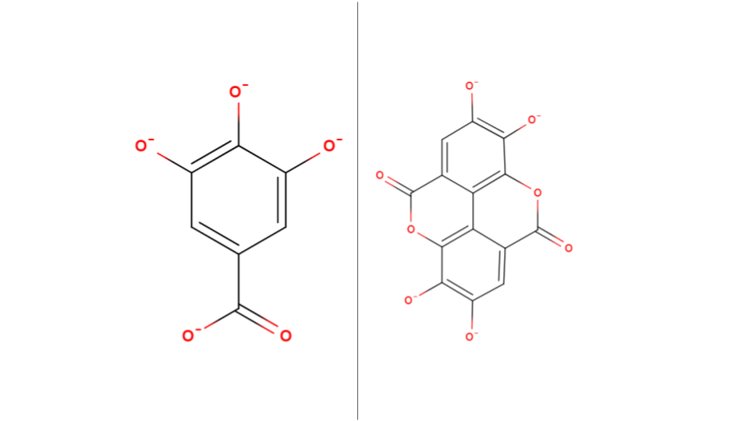

*Figure 14: Ionic structures of the gallate and ellagate anions (right to left). Negative charges marked on the oxygen atoms of the deprotonated hydroxyl groups. (MolView)*

However, the presence of excess hydroxide ions (OH-) in an alkaline environment can compete with the anions for binding with the copper ions. This competition may lead to the formation of insoluble copper hydroxide precipitates, which would decrease the availability of free copper ions to form complexes with the ligands from the PPP extract, thus affecting the EI.

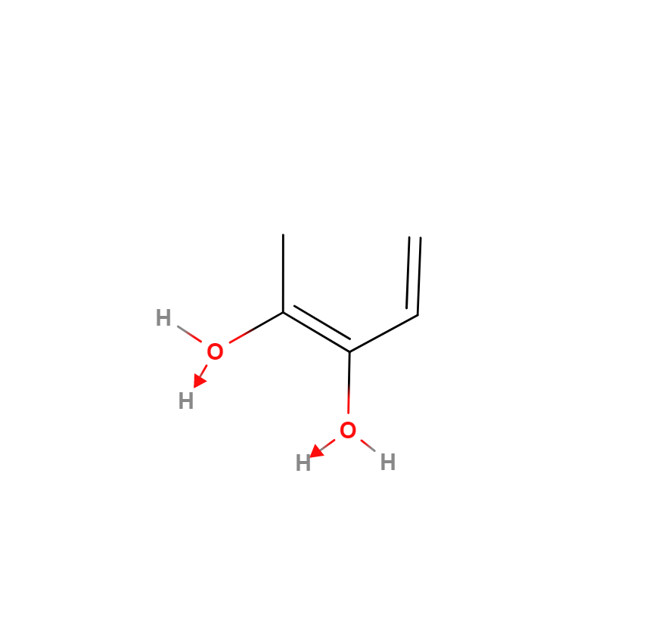The opposite effect is expected in acidic conditions. The increased protonation of the oxygen atom in the hydroxyl groups (due to the formation of a dative bond as shown in Figure 15) present in GA and EA should negatively affect complex formation since the oxygen atoms’ lone pairs are used for the protonation of the OHgroup, resulting in the loss of available binding sites in the ligands. Moreover, the excess H+ ions present in the acidic medium will compete with the already weakened ligands for the copper ions, further negatively affecting the EI.

*Figure 15: Protonation of the hydroxyl group in low pH environments* (MolView)*.*

## 4.9 Determination of Extent of Interaction

The most suitable method to determine the efficacy of the experiments is UV-Visible spectroscopy as it is a simple analytical technique which allows us to deduce the characteristics of metal-ligand complexes by their photon absorption at varying wavelengths(Edinburgh Instruments). This method hinges on the Beer-Lambert Law, which correlates the absorbance value provided by the spectrophotometer with the concentration of metal ions in the solution:

A = [2]

|  |
| --- |
| **A** = Absorbance value | **ε** = Molar absorption | **c** = Concentration | **l** = Path Length |

The spectrophotometer displays the amount of light absorbed by the solution in the cuvette. This absorbance value is inversely proportional to the metal-ligand complex concentration in the solution. Hence, in order to deduce the concentration of the remaining Cu2+ions in the solution, we use a curve that graphs absorbance against concentration.

The λmax value is the wavelength at which the Cu2+ion exhibits the highest absorbance. After chelation has occurred, we record the absorbance at the λmax wavelength to determine the complexing efficiency:

EI (%) = [3]

|  |
| --- |
| **EI** = Extent of interaction | **Am** = Absorbance of metal ion | **Ac** = Absorbance of complex solution |

# 

# 5 Hypothesis

## 5.1 Hypothesis 1 – Solvent Performance

As elaborated upon in Section 4.7, literature data suggests that methanol would be the most performant solvent compared to ethanol and water respectively as it strikes a balance between polarity and van Der Waals interactions (relative to ethanol and water), thus leading to higher complexation rates.

The diluted counterparts of methanol and ethanol should see a lower EI than the pure solutions since it has been established in Section 4.7that the water solvent is the least performant, thus, diluting methanol and ethanol should affect their ligand extraction efficiency.

|  |
| --- |
| **Methanol > Ethanol > Water > 50% Methanol > 50% Ethanol** |

## 5.2 Hypothesis 2 – Effect of PPP Mass Used

As the mass of the PPP used for extraction increases, the number of interacting species which could be extracted increases as well. As such, there should be a higher extraction yield and thus a higher ligand:Cu2+ ratio, leading to higher EI.

|  |
| --- |
| **0.05 > 0.025 > 0.01g** |

## 5.3 Hypothesis 3 – Effect of Metal Ion concentration

A higher concentration of the Cu2+ ion will result in more complexation as there will be a greater number of cations per unit volume, thus there will be a greater chance of the ligands complexing with the metal ion.

|  |
| --- |
| **0.075 > 0.05 > 0.025 moldm-3** |

## 5.4 Hypothesis 4 – Effect of Metal Ligand Voluminal Ratio

Due to the monodentate and bidentate nature of GA and EA respectively, the most optimal metal-to-ligand ratio would be around 2:3 (as there is a balance between the total number of binding sites in the Copper ions as well as the total number of binding sites in the ligands). This is followed by lower metal:ligand ratios due to the higher availability of ligands and then followed by higher metal:ligand ratios due to the lower availability of ligands.

|  |
| --- |
| **10:20 > 10:30 > 10:10 > 20:30 > 30:20 > 20:10 > 30:10** |

## 5.5 Hypothesis 5 – Effect of pH Environment

The EI of the PPP extract solution with copper is expected to be lower in acidic conditions as discussed in Section 4.8.

|  |
| --- |
| **pH 7 > pH 5 > pH 2** |

# 6 Preliminary Investigations

Preliminary studies were conducted in order to set the fixed variables and to determine a suitable range for the independent variables. The λmax for copper (II) sulfate solution was determined and an absorbance/concentration graph was plotted.

**6.4 UV-Vis Spectroscopy**

***6.4.1 Lambda Max Determination***

The determination of the λmax value is essential for this study as it will be used to determine the EI. The lambda scan graph for 0.05 moldm-3 CuSO4.xH2O solution (Graph 1) has a peak at 775 nm which was set as the λmax value.

*Graph 1: Graph of absorbance vs. wavelength for CuSO4(aq).*

***6.4.2 Standard Calibration Curve***

A standard/calibration curve is used to plot the linear relationship between the absorbance and concentration of a metal complex solution as according to Beer-Lambert’s Law. The λmax wavelength is used to measure the absorbance for each concentration. The high R2 value (0.977) proves the precision and reliability of the spectrophotometer used.

*Graph 2: Standard curve of CuSO4(aq) at λmax (775 nm)*

## 6.1 Selection of Extraction Method

Various extraction methods were tested – shaking, heating, and heated magnetic stirring – in order to determine which one would yield the highest degree of interaction. The heating mantle offered the highest complexation values and was thus chosen as the default extraction method for the study.

## 6.2 Selection of Boiling Duration

A range of boiling durations were chosen – 5, 10, and 15 minutes– in order to determine the extent to which thermal degradation and solvent solubility affects the metal interaction efficiency of the solutions. Finally, 5 minutes was chosen since the alcohol solutions experienced high levels of evaporation and were boiling off in extended boiling durations.

## 6.3 Selection of Solvents

Water, ethanol, methanol, and their binary equivalents were considered for the study as reasoned in Section 4.7.

## 6.4 Selection of PPP Mass

0.100, 0.050, 0.025 and 0.010 grams of PPP were used in the preliminary tests to determine the extent of extraction of ligands. 0.100g was not used for the actual study due to the complexed solutions being too turbid to make accurate spectrophotometric measurements.

# 7 Variables

## 7.1 Independent

|  |  |
| --- | --- |
| **Solvents** | Water, Ethanol, Methanol, 50% Ethanol, 50% Methanol |
| **Mass of PPP (g)** | 0.010, 0.025, 0.050 |
| **Concentration of Cu2+ (moldm-3)** | 0.025, 0.050, 0.075 |
| **Solution:Cu2+ Voluminal Ratio (cm3)** | 10:10, 10:20, 10:30, 20:10, 20:30, 30:10, 30:20 |
| **pH of complex solution** | 2, 5, 7 |

*Table 1: Independent variables*

## 7.2 Dependent

|  |
| --- |
| **Absorbance value for each solution at λmax** |
| **Calculated value of EI from the absorbance** |

*Table 2: Dependent variables*

# 8 Preparation of Reagents



## 8.1 Preparation of ligand solutions

**Step 1:** The 0.1g of PPP (as measured by the electronic top pan balance) is transferred to a beaker using a spatula.

**Step 2:** 50cm3 of solvent is added to the beaker (as measured by a 100cm3 measuring cylinder).

**Step 3:** The beaker is then placed in the heating mantle for the required duration at 100oC.

**Step 4:** After a cooldown period of one minute, the extraction solution is filtered to remove the PPP and 20cm3 of the solution is then transferred to a flask using a pipette.

## 8.2 Preparation of CuSO4 standards of varying concentrations

|  |  |
| --- | --- |
| **CuSO4 Concentration in (moldm-3)** | **Mass required for 100cm3 of standard (g)** |
| 0.025 | 0.624 ± 0.001 |
| 0.050 | 1.248 ± 0.001 |
| 0.075 | 1.872 ± 0.001 |
| The required mass of CuSO4 (Mr = 249.609) for each concentration was measured using an electronic top pan balance and diluted to 100.0 ± 0.5cm3 using a standard flask. Before use, the standard flasks were shaken thoroughly to ensure uniform composition. | |

## 8.3 Preparation of complex solutions

**Step 1:** The required volume of the ligand solution is transferred to a flask using a pipette.

**Step 2:** The required volume and concentration of the copper standard is added to the flask using a pipette.

**Step 3:** The flask is then left to equilibrate in the rotary shaker for 3 hours.

**Step 4:** Then a sample is taken from the complexed solution in the flask for further analysis.

## 8.4 Preparation of pH 2 buffer

### 8.4.1 Reagent 1 Preparation (0.20 moldm-3 Hydrochloric Acid)

**Step 1:** 1cm3 of Hydrochloric Acid solution was measured using a pipette then added to 50cm3 of distilled water in a measuring cylinder.

**Step 2:** The solution was transferred to a 100cm3 standard flask and the standard flask was filled with distilled water until the 100cm3 mark.

### 8.4.2 Reagent 2 Preparation (0.20 moldm-3 Potassium Chloride)

**Step 1:** 1.490g of Potassium Chloride was weighed on a digital scale.

**Step 2:** The salt was then transferred to a beaker containing 50cm3 distilled water and the solution was stirred thoroughly.

**Step 3:** The solution was transferred to a 100cm3 standard flask and the standard flask was filled with distilled water until the 100cm3 mark.

### 8.4.3 Buffer Preparation

**Step 1:** Using a measuring cylinder, 13.0±0.5 cm3of Reagent 1 was measured and transferred to a 250cm3 beaker.

**Step 2:** Using a measuring cylinder, 50±0.5 cm3of Reagent 2 was measured and transferred to the same 250cm3 beaker containing Reagent 1.

**Step 3:** Using a measuring cylinder, 137±0.5 cm3 of distilled water was measured and transferred to the aforementioned 250cm3 beaker to obtain pH 2 buffer solution.

## 8.5 Preparation of pH 5 buffer

### 8.5.1 Reagent 1 Preparation (0.10 moldm-3 Glacial Acetic Acid)

**Step 1:** 0.600g of Glacial Acetic Acid was weighed on a digital scale.

**Step 2:** The salt was then transferred to a beaker containing 50cm3 distilled water and the solution was stirred thoroughly.

**Step 3:** The solution was transferred to a 100cm3 standard flask and the standard flask was filled with distilled water until the 100cm3 mark.

### 8.5.2 Reagent 2 Preparation (0.10 moldm-3 Sodium Acetate Trihydrate)

**Step 1:** 1.362g of Sodium Acetate Trihydrate was weighed on a digital scale.

**Step 2:** The salt was then transferred to a beaker containing 50cm3 distilled water and the solution was stirred thoroughly.

**Step 3:** The solution was transferred to a 100cm3 standard flask and the standard flask was filled with distilled water until the 100cm3 mark.

### 8.5.3 Buffer Preparation

**Step 1:** Using a measuring cylinder, 59.0±0.5 cm3of Reagent 1 was measured and transferred to a 250cm3 beaker.

**Step 2:** Using a measuring cylinder, 141±0.5 cm3of Reagent 2 was measured and transferred to the same 250cm3 beaker containing Reagent 1 to obtain pH 5 buffer solution.

## 8.6 Preparation of pH 7 buffer

**Step 1:** Using a measuring cylinder, 100±0.5 cm3 of distilled water was measured and transferred to a 100cm3 beaker.

**Step 2:** The contents of a pH 7 buffer preparation capsule was added to the beaker and the solution was stirred thoroughly to obtain pH 7 buffer solution.

## 8.7 Preparation of complex solutions with buffer

**Step 1:** The required volume of the ligand solution is transferred to a flask using a pipette.

**Step 2:** 5cm3 of the required buffer is added to the ligand solution using a pipette.

**Step 3:** The required volume and concentration of the copper standard is added to the flask using a pipette.

**Step 4:** The flask is then left to equilibrate in the rotary shaker for 3 hours.

**Step 5:** Then a sample is taken from the complexed solution in the flask for further analysis.

# 9 Data Collection

The calculations for the uncertainties of the varying concentrations of metal ion solutions are given in the Appendix (Section 16.1.1).

## 9.1 Qualitative Data

|  |  |
| --- | --- |
| 9.1.1 Complex Solutions for Varying Solvents | |
| **Water** | - |
| **Ethanol** | - |
| **Methanol** | - |
| **50% Ethanol** | - |
| **50% Methanol** | - |

*Table 3: Qualitative data for the complexed solutions for varying solvents.*

|  |  |  |  |
| --- | --- | --- | --- |
| 9.1.2 Complex Solutions at Varying PPP Mass (± 0.001) (g) | | | |
| **Solvent/Mass** | **0.010** | **0.025** | **0.050** |
| **Water** | - | - | - |
| **Ethanol** | - | - | - |
| **Methanol** | - | - | - |
| **50% Ethanol** | - | - | - |
| **50% Methanol** | - | - | - |

*Table 4:* *Qualitative data for the complexed solutions for varying PPP mass (g).*

|  |  |  |  |
| --- | --- | --- | --- |
| 9.1.3 Complex Solutions at Varying Copper Concentrations (moldm-3) | | | |
| **Solvent/Concentration** | **0.025 ± 1.65×10-4** | **0.050 ± 1.45×10-4** | **0.075 ± 1.38×10-4** |
| **Water** | - | - | - |
| **Ethanol** | - | - | - |
| **Methanol** | - | - | - |
| **50% Ethanol** | - | - | - |
| **50% Methanol** | - | - | - |

*Table 5: Qualitative data for the complexed solutions for varying copper concentration (moldm-3).*

|  |  |
| --- | --- |
| 9.1.4 Complex Solutions for Varying Water:Cu2+ Voluminal Ratios (cm3) | |
| **10:10** | - |
| **10:20** | - |
| **10:30** | - |
| **20:10** | - |
| **20:30** | - |
| **30:10** | - |
| **30:20** | - |

*Table 6: Qualitative data for the complexed solutions for varying voluminal ratios (cm3).*

|  |  |  |  |  |
| --- | --- | --- | --- | --- |
| 9.1.5 Complex Solutions at Varying pH and PPP Mass (± 0.001) (g) (0.050M Cu2+) | | | | |
| **pH** | **Solvent/Mass** | **0.025** | **0.050** | **0.075** |
| **2** | **Water** | - | - | - |
| **50% Ethanol** | - | - | - |
| **5** | **Water** | - | - | - |
| **50% Ethanol** | - | - | - |
| **7** | **Water** | - | - | - |
| **50% Ethanol** | - | - | - |

*Table 7: Qualitative data for the complexed solutions for varying pH and PPP mass (g) at 0.05M copper conc.*

|  |  |  |  |  |
| --- | --- | --- | --- | --- |
| 9.1.6 Complex Solutions at Varying pH and PPP Mass (± 0.001) (g) (0.075M Cu2+) | | | | |
| **pH** | **Solvent/Mass** | **0.025** | **0.050** | **0.075** |
| **2** | **Water** | - | - | - |
| **50% Ethanol** | - | - | - |
| **5** | **Water** | - | - | - |
| **50% Ethanol** | - | - | - |
| **7** | **Water** | - | - | - |
| **50% Ethanol** | - | - | - |

*Table 8: Qualitative data for the complexed solutions for varying pH and PPP mass (g) at 0.075M copper conc.*

## 9.2 Quantitative Data – Absorbance Value

|  |  |
| --- | --- |
| 9.2.1 Complex Solutions for Varying Solvents | |
| **Water** | 0.123 |
| **Ethanol** | 0.117 |
| **Methanol** | 0.062 |
| **50% Ethanol** | 0.233 |
| **50% Methanol** | 0.210 |

*Table 9: Quantitative data for the complexed solutions for varying solvents.*

|  |  |  |  |
| --- | --- | --- | --- |
| 9.2.2 Complex Solutions at Varying PPP Mass (± 0.001) (g) | | | |
| **Solvent/Mass** | **0.010** | **0.025** | **0.050** |
| **Water** | 0.177 | 0.135 | 0.123 |
| **Ethanol** | 0.258 | 0.208 | 0.117 |
| **Methanol** | 0.185 | 0.107 | 0.062 |
| **50% Ethanol** | 0.263 | 0.205 | 0.233 |
| **50% Methanol** | - | - | 0.210 |

*Table 10:* *Quantitative data for the complexed solutions for varying PPP mass (g).*

|  |  |  |  |
| --- | --- | --- | --- |
| 9.2.3 Complex Solutions at Varying Copper Concentrations (moldm-3) | | | |
| **Solvent/Concentration** | **0.025 ± 1.65×10-4** | **0.050 ± 1.45×10-4** | **0.075 ± 1.38×10-4** |
| **Water** | 0.116 | 0.123 | 0.182 |
| **Ethanol** | 0.119 | 0.117 | 0.186 |
| **Methanol** | 0.154 | 0.062 | 0.135 |
| **50% Ethanol** | 0.107 | 0.233 | 0.269 |
| **50% Methanol** | 0.228 | 0.210 | 0.182 |

*Table 11: Quantitative data for the complexed solutions for varying copper concentration (moldm-3).*

|  |  |  |  |  |  |  |  |  |  |  |  |  |  |  |  |  |  |  |  |  |  |  |  |  |  |  |  |  |  |  |  |  |  |  |  |  |  |  |  |  |  |  |  |  |  |  |  |  |  |  |  |  |  |  |  |  |  |
| --- | --- | --- | --- | --- | --- | --- | --- | --- | --- | --- | --- | --- | --- | --- | --- | --- | --- | --- | --- | --- | --- | --- | --- | --- | --- | --- | --- | --- | --- | --- | --- | --- | --- | --- | --- | --- | --- | --- | --- | --- | --- | --- | --- | --- | --- | --- | --- | --- | --- | --- | --- | --- | --- | --- | --- | --- | --- |
| |  |  | | --- | --- | | 9.2.4 Complex Solutions for Varying Water:Cu2+ Voluminal Ratios (cm3) | | | **10:10** | - | | **10:20** | 0.189 | | **10:30** | 0.210 | | **20:10** | 0.123 | | **20:30** | 0.207 | | **30:10** | 0.747 | | **30:20** | - |   *Table 12: Quantitative data for the complexed solutions for varying voluminal ratios (cm3).*   |  |  |  |  |  | | --- | --- | --- | --- | --- | | 9.2.5 Complex Solutions at Varying pH and PPP Mass (± 0.001) (g) (0.050M Cu2+) | | | | | | **pH** | **Solvent/Mass** | **0.025** | **0.050** | **0.075** | | **2** | **Water** | 0.063 | 0.107 | 0.085 | | **50% Ethanol** | 0.114 | 0.162 | 0.138 | | **5** | **Water** | 0.085 | 0.234 | 0.097 | | **50% Ethanol** | 0.072 | 0.152 | 0.223 | | **7** | **Water** | 0.271 | 0.171 | 0.163 | | **50% Ethanol** | 0.275 | 0.304 | 0.263 | | | | | |
| *Table 13: Quantitative data for the complexed solutions for varying pH and PPP mass (g) at 0.05M copper conc.* | | | | |
|  | | | | |
| 9.2.6 Complex Solutions at Varying pH and PPP Mass (± 0.001) (g) (0.075M Cu2+) | | | | |
| **pH** | **Solvent/Mass** | **0.025** | **0.050** | **0.075** |
| **2** | **Water** | 0.127 | 0.141 | - |
| **50% Ethanol** | 0.163 | 0.142 | 0.276 |
| **5** | **Water** | - | - | 0.130 |
| **50% Ethanol** | 0.135 | - | - |
| **7** | **Water** | - | - | - |
| **50% Ethanol** | - | - | - |

*Table 14: Quantitative data for the complexed solutions for varying pH and PPP mass (g) at 0.075M copper conc.*

# 10 Data Processing – EI%

|  |  |  |  |  |
| --- | --- | --- | --- | --- |
| **Sample Data Processing (for EI%)** | | | | |
| **Solvent** | **PPP Mass (g)** | **Copper standard concentration (moldm-3)** | **Absorbance of complex solution at 775 nm (Ac)** | **Absorbance of 0.05 moldm-3 at 775 nm (Am)** |
| Water | 0.01± 0.001 | 0.050 ± 1.45×10-4 | 0.177 | 0.277 |
| *[Equation 2]* Interaction Efficiency (%) = = = **36%** | | | | |

|  |  |
| --- | --- |
| 10.1 Complex Solutions for Varying Solvents | |
| **Water** | 56 |
| **Ethanol** | 58 |
| **Methanol** | 78 |
| **50% Ethanol** | 16 |
| **50% Methanol** | 24 |

*Table 15: IE% data for the complexed solutions for varying solvents.*

|  |  |  |  |
| --- | --- | --- | --- |
| 10.2 Complex Solutions at Varying PPP Mass (± 0.001) (g) | | | |
| **Solvent/Mass** | **0.010** | **0.025** | **0.050** |
| **Water** | 36 | 51 | 56 |
| **Ethanol** | 7 | 25 | 35 |
| **Methanol** | 33 | 61 | 78 |
| **50% Ethanol** | 30 | 26 | 16 |
| **50% Methanol** | - | - | 24 |

*Table 16: IE% data for the complexed solutions for varying PPP mass (g).*

|  |  |  |  |
| --- | --- | --- | --- |
| 10.3 Complex Solutions at Varying Copper Concentrations (moldm-3) | | | |
| **Solvent/Concentration** | **0.025 ± 1.65×10-4** | **0.050 ± 1.45×10-4** | **0.075 ± 1.38×10-4** |
| **Water** | 58 | 56 | 34 |
| **Ethanol** | 57 | 58 | 33 |
| **Methanol** | 44 | 78 | 51 |
| **50% Ethanol** | 61 | 16 | 3 |
| **50% Methanol** | 18 | 24 | 34 |

*Table 17: IE% data for the complexed solutions for varying copper concentration (moldm-3).*

|  |  |
| --- | --- |
| 10.4 Complex Solutions for Varying Water:Cu2+ Voluminal Ratios (cm3) | |
| **10:10** | - |
| **10:20** | 32 |
| **10:30** | 24 |
| **20:10** | 56 |
| **20:30** | 25 |
| **30:10** | -170 |
| **30:20** | - |

*Table 18: IE% data for the complexed solutions for varying voluminal ratios (cm3).*

|  |  |  |  |  |
| --- | --- | --- | --- | --- |
| 10.5 Complex Solutions at Varying pH and PPP Mass (± 0.001) (g) (0.050M Cu2+) | | | | |
| **pH** | **Solvent/Mass** | **0.025** | **0.050** | **0.075** |
| **2** | **Water** | 77 | 61 | 69 |
| **50% Ethanol** | 59 | 42 | 50 |
| **5** | **Water** | 69 | 16 | 65 |
| **50% Ethanol** | 74 | 45 | 19 |
| **7** | **Water** | 2 | 38 | 41 |
| **50% Ethanol** | 1 | -10 | 5 |

*Table 19: IE% data for the complexed solutions for varying pH and PPP mass (g) at 0.050M copper conc.*

|  |  |  |  |  |
| --- | --- | --- | --- | --- |
| 10.6 Complex Solutions at Varying pH and PPP Mass (± 0.001) (g) (0.075M Cu2+) | | | | |
| **pH** | **Solvent/Ratio** | **0.025** | **0.050** | **0.075** |
| **2** | **Water** | 54 | 49 | - |
| **50% Ethanol** | 41 | 49 | 0 |
| **5** | **Water** | - | - | 53 |
| **50% Ethanol** | 51 | - | - |
| **7** | **Water** | - | - | - |
| **50% Ethanol** | - | - | - |

*Table 20: IE% data for the complexed solutions for varying pH and PPP mass (g) at 0.075M copper conc.*

# 11 Analysis

## 11.1 Analysis 1 – Solvent Performance

Graph 3 shows the EI of various solvents at the same extraction and complexation conditions. The first trend to note is the fall in EI from methanol to ethanol/water (~20%). The next trend is the fall in EI from methanol to 50% methanol (54%) and ethanol to 50% ethanol (42%). These readings mostly corroborate with **Hypothesis 1** - methanol is by far the most performant solvent, while the diluted counterpart of ethanol is the least performant.

*Graph 3: IE of various solvents (0.05g PPP;**0.05M Cu2+; 10:20)*

Water’s EI is comparable to that of ethanol. This deviation from the expected trend shows that the water solvent has a similar extraction yield to that of ethanol, which is not justified by the chemical interactions that take between the water molecules and GA and EA. Hence, water’s abnormal EI could be **explained by the extraction of other highly polar ligands from** PPP which complex with the copper atoms, seeing that, as mentioned in Section 4.5, non-GA and EA polyphenols such as catechin and epicatechin make up 20-40% of the peel (Figure 5). **Moreover, due to their smaller size, water molecules may have been able to penetrate the PP matrix to a greater extent than the other solvents, leading to higher-than-expected extraction efficiency and thus higher EI (literature data validates this reasoning in that a greater penetration of the peel matrix results in higher extraction yields** (Kaderides, Goula and Adamopoulos)). The literature references used in *Section 4.7* used commercially-available GA and EA which didn’t have to be extracted through the PP matrix – this was not accounted for in the framing of **Hypothesis 1**, leading to water’s unexpected EI value.

## 11.2 Analysis 2 – Effect of PPP Mass Used

Graph 4 shows the EI of using varying PPP mass for different solvents at the same extraction and complexation conditions. It can be observed that there is an increase in EI with mass for all solvents. These values fall in line with the predicted trend in **Hypothesis 2**.

*Graph 4: IE of various PPP masses (0.05M Cu2+; 10:20)*

The observed plateau of the plotted lines as the PPP mass increases can be explained through the solubility limits of the solvents. As the extraction process progresses and more ligands are dissolved in the solvent, the **solution approaches its maximum solubility limit. At this point the extraction rate declines and thus the extraction efficiency at higher masses falls as well. This leads to the plateauing effect in the EI with higher mass. The extent of the plateauing will vary based on the specific solubility limit of each solvent.**

## 11.3 Analysis 3 – Effect of Metal Ion concentration

Graph 5shows the EI of using differing copper concentrations for different solvents and masses at the same extraction and complexation conditions.

## 11.4 Analysis 4 – Effect of Metal Ligand Voluminal Ratio

*Graph 5: IE of various metal ion concentrations (0.05g PPP; 10:20)*

# 12 Conclusion

This investigation elucidates the potent chelating prowess of phenolic acid derivatives extracted from PPP in complexing with aqueous Copper (II) ions, and hence spotlighting a viable, environmentally friendly method for mitigating heavy metal contamination in water bodies. Furthermore, the study has also probed into the optimal conditions required in order to achieve the maximum interaction. The findings thus illuminate a pathway for fostering a 'green chemistry' approach to water remediation.

*Graph 6: IE of various voluminal ratios (0.05g PPP; 10:20)*

# 13 Evaluation

|  |
| --- |
| 13.1 Strengths |
| * The study leverages organic waste products (PPs) for water remediation; hence the side-effects of synthetic alternatives (EDTA) are avoided (Section 4.3). * The utilization of a spectrum of readily available organic solvents ensures limited environmental impact at relatively lower costs while achieving a high EI. * Using a UV-Visible spectrophotometer ensures a high degree of reliability in the measurements of the degree of interaction between the metal and ligand solution. * Granulation of PPs results in an increase in its surface area - this technique being chosen in order to maximize the efficiency of ligand extraction and allow for greater penetration of the plant matrix. |

*Table 21: Strengths of study*

|  |  |
| --- | --- |
| 13.2 Weaknesses | |
| Systematic Errors | Random Errors |
| * The ligand extraction solution may have contained competing polyphenols which could not be eliminated, possibly hindering the expected results. * Although preventative measures were taken, the decomposition of the PPP in storage would have resulted in the degradation of the polyphenols within the peel (Fawole and Opara), negatively affecting the EI values for later studies. | * The preparation of the analytes was conducted only once, which compromises the general reliability of results. Repetition of the tests would result in increased reliability of results. |

*Table 22: Weaknesses of study*

# 14 Further Scope

The study has been limited to only using Cu2+, hence other heavy metal ions such as Ni and Zn which are also present in heavy metal contaminated water (Mokarram, Saber and Sheykhi) could have been used to determine PPP’s efficacy in scavenging with them. Moreover, the study could have incorporated various species of PPs in order to determine how differences in geography could affect the degree of interaction with the metal ion. The PPs could have undergone pre-processing (ex. sun-drying, freeze-drying etc.) prior to granulation in order to determine its effects on its water remediation performance.

# 15 References

n.d. 13 February 2024. <https://pubchem.ncbi.nlm.nih.gov/>.

Araya, Magdalena, Manuel Olivares and Fernando Pizarro. "Copper in human health." *International Journal of Environment and Health* 1.4 (2007): 609, 615.

Bala, I., et al. "Analytical methods for assay of ellagic acid and its solubility studies." *Journal of Pharmaceutical and Biomedical Analysis* 40.1 (2006): 209.

Barret, Jack. *Inorganic chemistry in aqueous solution*. Vol. 21. London: Royal Society of Chemistry, 2003. 20 February 2024. <https://books.rsc.org/books/monograph/307/Inorganic-Chemistry-in-Aqueous-Solution>.

Belščak-Cvitanović, Ana, et al. "Overview of polyphenols and their properties." *Polyphenols: Properties, Recovery, and Applications* (2018): 3, 12, 16-18.

Brown, Catrin and Mike Ford. *Higher Level Chemistry 2nd Edition*. 2. Harlow: Pearson Baccalaureate, 2014. Book.

Chieh, Chung (Peter). *Hydration*. n.d. 16 February 2024. <https://chem.libretexts.org/Bookshelves/Physical_and_Theoretical_Chemistry_Textbook_Maps/Supplemental_Modules_(Physical_and_Theoretical_Chemistry)/Thermodynamics/Energies_and_Potentials/Enthalpy/Hydration>.

Clark, Jim. *COPPER*. July 2015. 12 February 2024. <https://www.chemguide.co.uk/inorganic/transition/copper.html>.

Crisponi, Guido, et al. "Kill or cure: Misuse of chelation therapy for human diseases." *Coordination Chemistry Reviews* 284 (2014): 4.

Daneshfar, Ali, Hassan S. Ghaziaskar and Nasrolah Homayoun. "Solubility of Gallic Acid in Methanol, Ethanol, Water, and Ethyl Acetate." *Journal of Chemical & Engineering Data* 53.2 (2008): 1.

Derakhshan, Zahra, et al. "Antioxidant activity and total phenolic content of ethanolic extract of pomegranate peels, juice and seeds." *Food and Chemical Toxicology* 114 (2018): 3.

Edinburgh Instruments. *Techniques: Uv-Vis Spectroscopy*. n.d. 21 December 2023. <https://www.edinst.com/in/techniques/uv-vis-spectroscopy/>.

Fawole, Olaniyi Amos and Umezuruike Linus Opara. "Effects of storage temperature and duration on physiological responses of pomegranate fruit." *Industrial Crops and Products* 47 (2013): 301, 303.

Flora, Swaran J.S. and Vidhu Pachauri. "Chelation in Metal Intoxication." *International journal of environmental research and public health* 7.7 (2010): 2.

Görgüç, Ahmet, Esra Gençdağ and Fatih Mehmet Yılmaz. "Industrial Pomegranate Wastes and their Functional Benefits in Novel Food Formulations." *Mediterranean Fruits Bio-wastes: Chemistry, Functionality and Technological Applications* (2022): 721. 1 February 2024. <https://link.springer.com/chapter/10.1007/978-3-030-84436-3_31>.

Hinck, Ferguson and Puhaakka. "Resistance of EDTA and DTPA to Aerobic Biodegradation." *Water Science & Technology* 35.2-3 (1997): 7.

Kaderides, Kyriakos, Athanasia M. Goula and Konstantinos G. Adamopoulos. "A process for turning pomegranate peels into a valuable food ingredient using ultrasound-assisted extraction and encapsulation." *Innovative Food Science and Emerging Technologie* 31 (2015): 13. 23 February 2024. <https://www.sciencedirect.com/science/article/abs/pii/S1466856415001617>.

Kupnik, Kaja, et al. "Supercritical Fluid and Conventional Extractions of High Value-Added Compounds from Pomegranate Peels Waste: Production, Quantification and Antimicrobial Activity of Bioactive Constituents." *Plants* 11.7 (2022): 8.

Lancashire, Robert J. *Stability of Metal Complexes and Chelation*. n.d. 6 February 2024. <https://chem.libretexts.org/Bookshelves/Inorganic_Chemistry/Supplemental_Modules_and_Websites_(Inorganic_Chemistry)/Coordination_Chemistry/Complex_Ion_Equilibria/Stability_of_Metal_Complexes_and_Chelation>.

LibreTexts. "Colors of Coordination Complexes." n.d. *LibreTexts Chemistry.* 6 February 2024. <https://chem.libretexts.org/Bookshelves/Inorganic_Chemistry/Supplemental_Modules_and_Websites_%28Inorganic_Chemistry%29/Crystal_Field_Theory/Colors_of_Coordination_Complexes>.

Lo, Irene M.C. and X. Y. Yang. "EDTA Extraction of Heavy Metals from Different Soil Fractions and Synthetic Soils." *Water, Air, and Soil Pollution* 109 (1997): 225.

Lucidchart. *Lucidchart*. n.d. 3 December 2023. <https://www.lucidchart.com/pages>.

Manne, Ravi, et al. "Water quality and risk assessment of copper content in drinking water stored in copper container." *Applied Water Science* 12.3 (2022): 3, 5-6.

Mo, Yaxian, et al. "Pomegranate Peel as a Source of Bioactive Compounds: A Mini Review on Their Physiological Functions." *Frontiers in Nutrition* 9 (2022): 2-3.

Mokarram, Marzieh, Ali Saber and Vahideh Sheykhi. "Effects of heavy metal contamination on river water quality due to release of industrial effluents." *Journal of Cleaner Production* 277 (2020): 18, 23-24.

MolView. *MolView*. n.d. 2 December 2023. <https://molview.org>.

Rashed, Musaab K. and Wissam Tayh. "Removal of Heavy Metals from Wastewater Using Pomegranate Peel." *IOP Conference Series: Materials Science and Engineering* (2020): 1-2.

Rasouli, Hassan, Mohammad Hosein Farzaei and Reza Khodarahmi. "Polyphenols and their benefits: A review." *International Journal of Food Properties* 20.2 (2017): 1-2.

Rehman, Kanwal, et al. "Prevalence of Exposure of Heavy Metals and Their Impact on Health Consequences." *Journal of Cellular Biochemistry* (2017): 2.

U.S. Congress, Office of Technology Assessment. *Copper: Technology and Competitiveness*. Office of Technology Assessment, 1988. 16 January 2024. <https://www.princeton.edu/~ota/disk2/1988/8808/8808.PDF>.

United Nations. *Goal 6*. 2022. 17 January 2024. <https://sdgs.un.org/goals/goal6>.

Water.org. *An Economic Crisis*. n.d. 17 January 2024. <https://water.org/our-impact/water-crisis/economic-crisis/>.

Yoder, Claude H. and Natalie J. Flora. "Geochemical applications of the simple salt approximation to the lattice energies of complex materials." *American Mineralogist* 90.2-3 (2005): 492. 20 February 2024. <https://www.degruyter.com/document/doi/10.2138/am.2005.1537/html>.

Zarfeshany, Aida, Sedigheh Asgary and Shaghayegh Haghjoo Javanmard. "Potent health effects of pomegranate." *Advanced Biomedical Research* 3.1 (2014): 1-6.

# 16 Appendix

## 16.1 Uncertainties

### 16.1.1 Varying copper standards

|  |  |
| --- | --- |
| The fractional uncertainty of the concentration of the standards are calculated by:  **c** = metal concentration (moldm3) | **m** = Mr of CuSO4 | **v** = volume of water added  For 0.025 moldm-3:  This calculation is repeated for the other standard concentrations: | |
| 0.05 moldm-3 | ±1.45×10-4 |
| 0.075 moldm-3 | ±1.38×10-4 |